

Predicting Hotel Booking Behaviour:

Domain: Hospitality / Customer Analytics – Hotel Booking Analysis
Tool used: Python - Google Colab

“Can a customer’s booking characteristics, stay details and booking preferences be used to explain and predict their likelihood of cancelling a hotel reservation?”


Submitted To: Dr. Manohar Kapse

Submitted By:
Raj Verma | JI25PG119
Prabhanshu Manas Dubey | JI25PG193
Kushagra Gupta | JI25PG192

1. Problem Statement

1a. Domain of the study
Hospitality and tourism, specifically hotel revenue management, which sits at the intersection of marketing (distribution channels, customer segments, pricing) and operations (inventory and capacity planning).

1b. Broad problem of the study
Booking cancellations are one of the largest sources of revenue uncertainty for hotels. In this dataset 37.0% of all bookings (44,224 of 119,390) were cancelled. A cancelled room that is not resold leaves revenue unrealised, while the common defensive response of overbooking risks walking guests to other hotels. The broad problem is therefore:
"Can a hotel predict, at the time of booking, whether a reservation will be cancelled, and which booking characteristics drive cancellation?"
This is a supervised binary classification problem. Predicting cancellation risk lets a hotel manage overbooking, deposit and reminder policies and channel strategy on evidence rather than intuition.

2. Variables of the Study
The dataset has 32 variables. The table below lists all of them with their type. "Scale" variables are numeric measures; "Categorical" variables are labels or codes (including binary indicators and ID-like codes).
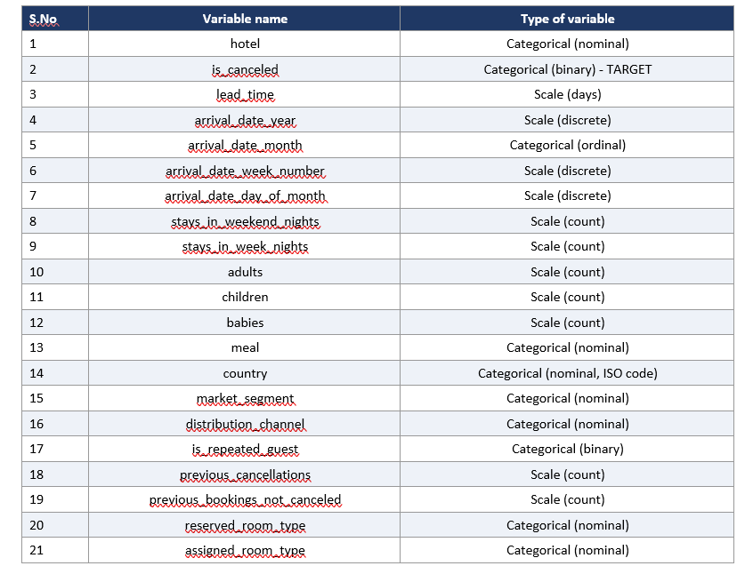Table 1: Variables of the study
Important: reservation status and reservation_status_date record what finally happened to the booking, so they would "leak" the answer and are excluded from the models. agent and company are anonymised identifiers rather than measurements, so they are also excluded from modelling (they remain in the descriptive tables for completeness).

3. Descriptive Statistics for Scale Variables
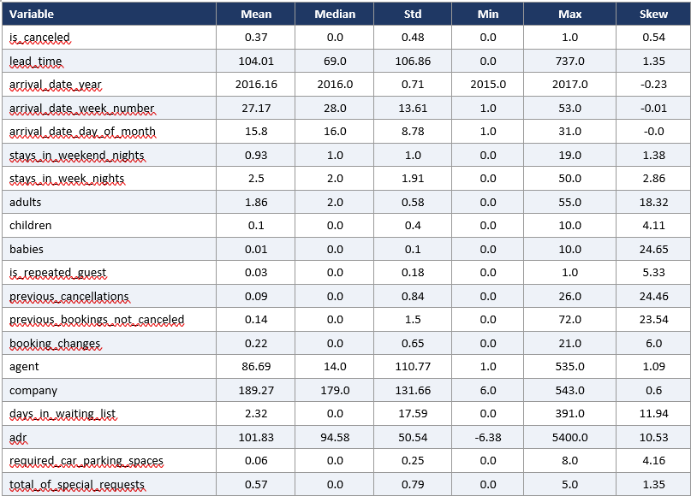Table 2: Descriptive statistics of scale variables (is_canceled shown as a 0/1 indicator; its mean is the cancellation rate)

3a. Description of variables:
•lead_time: Mean 104 days, median 69, maximum 737. Since the mean is above the median and the skewness is 1.35, the distribution is right-skewed, with most guests booking within a couple of months, and a long tail booking more than a year in advance. This was the case for cancelled bookings, in which the average lead time was 145 days compared to 80 days for honoured bookings, the strongest numeric correlation of cancellation was r = 0.29.
•adr: Mean 101.8 with median 94.6, but a maximum of 5,400 and a negative minimum (-6.38). This skew of 10.5 is caused by a single extreme record as well as some invalid values—these are data quality problems—not actual prices. It shows a low level of correlation with cancellation (0.05).
Typical stays are estimated to be approximately 1 weekend night (stays_in_weekend_nights) and 2 week nights (stays_in_week) (means 0.93 and 2.50 respectively). The maximum Night stays are 19 and 50, which are very rare. However, the meaning is neither very close to the cancellation (r = 0.00 or 0.03) nor is it very high.
Adults, children, babies: Average of 2 adults (mean 1.86, median 2) and virtually none of children (mean 0.10) or babies (0.01). The maximum capacity for group bookings or likely entry error of 55 adults and 10 babies – children values are missing. With an IQR of 0, adults has 24.9% IQR outliers.
Both previous_cancellations and previous_bookings_not_canceled are heavily skewed (around 24) as the booking history is missing for around 92% of bookings. In the minority with history, previous cancellations are a very powerful warning (r = 0.11 overall, and the best positive driver in the logistic model).
•booking_changes: Mean 0.22. Only 85% of bookings are not changed and those changed cancel less often (r = -0.14) indicating that amendment signifies commitment.
•total_of_special_requests: Mean of 0.57, required_car_parking_spaces: Mean of 0.06. The two variables that are most negatively related to cancellation (r = -0.24 and -0.20) are: a guest who has asked for something and a guest who has reserved parking. None of those that had reserved a parking space were cancelled, which is why the models treat parking as a very strong signal – compared to those that had not reserved a parking space, which had 39.5% cancellations.
•days_in_waiting_list: Mean 2.3 but 96.9% are zero and the maximum is 391 - an extremely skewed, mostly empty variable with a very weak relationship to cancellation (0.05).
Time indicators for the years 2015-2017: arrival_date_year, week_number, day_of_month. The use of weeks (1–53) and days (1–31) is basically symmetric and there is no linear relation with the cancellation, seasonality is better observed by month (Section 4).
The means of agent and company are not meaningful numeric codes and the percent of means that are missing is 94.3% and 13.7%, respectively (see Section 5).

3b. Graphs and charts
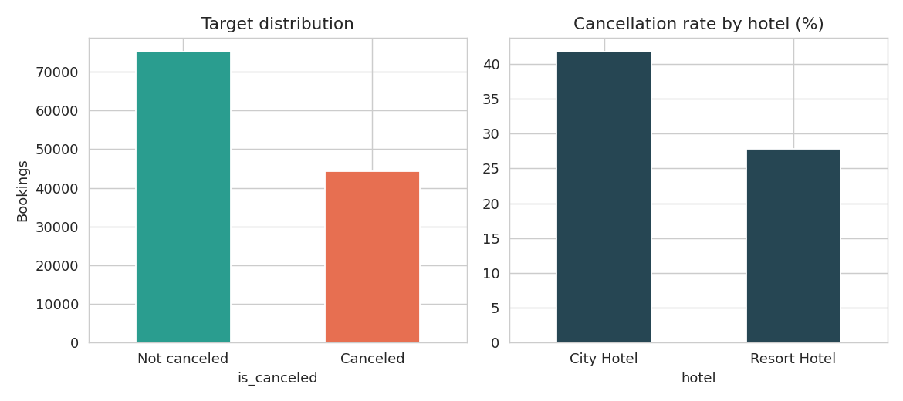
Figure 1: Target distribution and cancellation rate by hotel type
Figure 1 shows that 63.0% of bookings are honoured and 37.0% are cancelled - an imbalanced but not extreme target. City Hotel cancels far more (41.7%) than Resort Hotel (27.8%), consistent with city stays being more often for business or flexible trips.
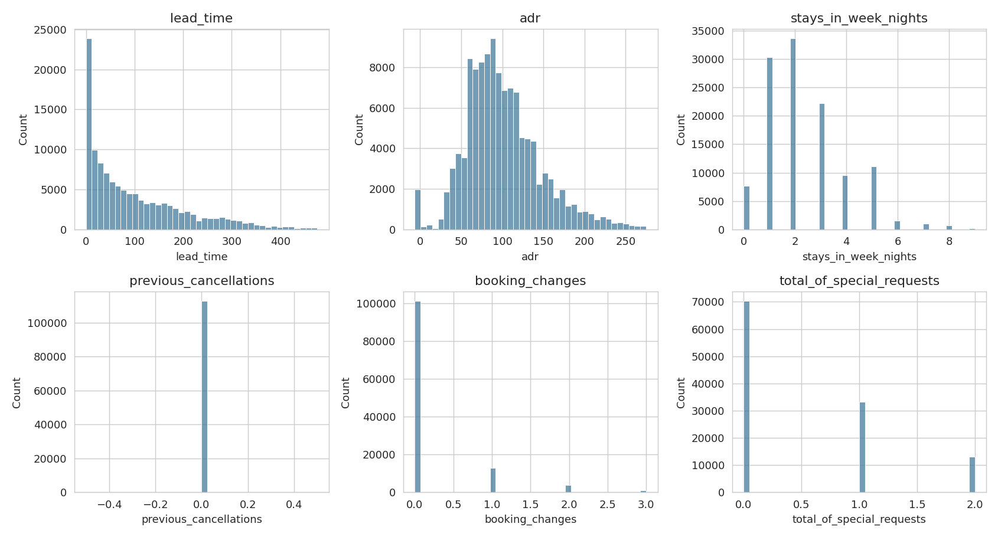
Figure 2: Distribution of key scale variables (top 0.5% trimmed for readability)
Figure 2 confirms the strong right skew in lead time, ADR, stay length and the zero-inflated shape of previous cancellations, booking changes and special requests. These shapes justify tree-based models and scaling for the linear model.
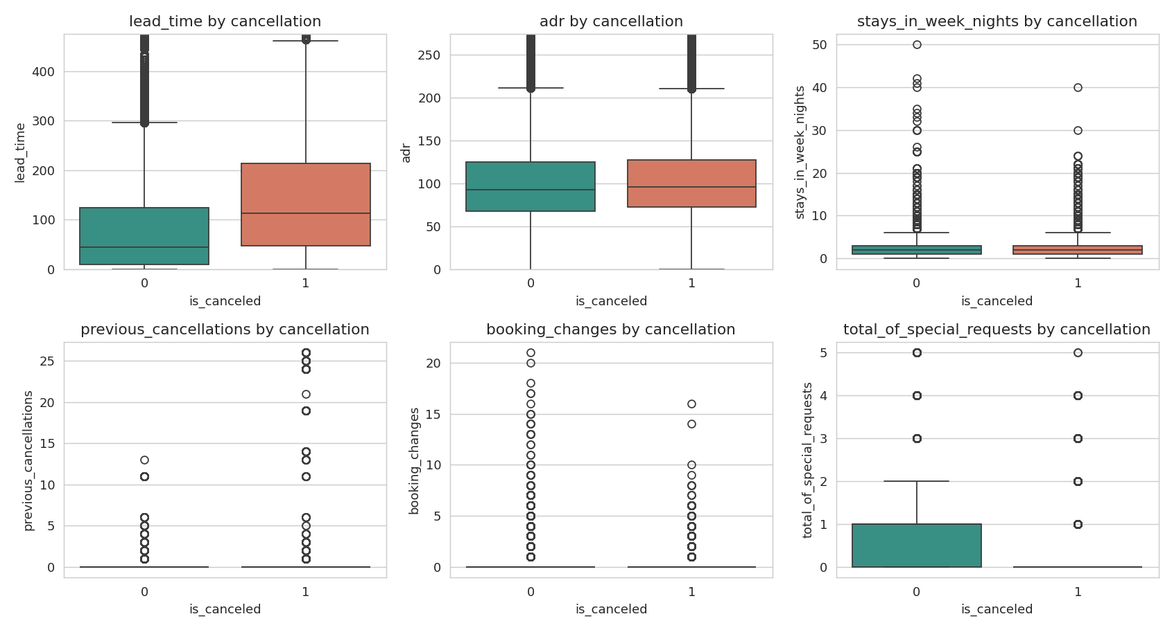
Figure 3: Key scale variables by cancellation status
Cancelled bookings were made much earlier (higher lead_time), had more prior cancellations, and had fewer special requests and booking changes. ADR and weeknight stays look nearly identical across the two groups.

Outliers (IQR rule)
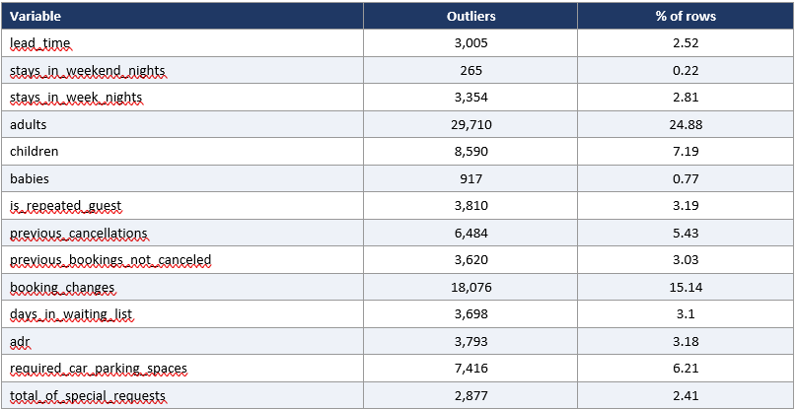Table 3: IQR outlier counts. Most flagged values are genuine rare behaviour (not errors) and were retained, since tree models are robust to them.
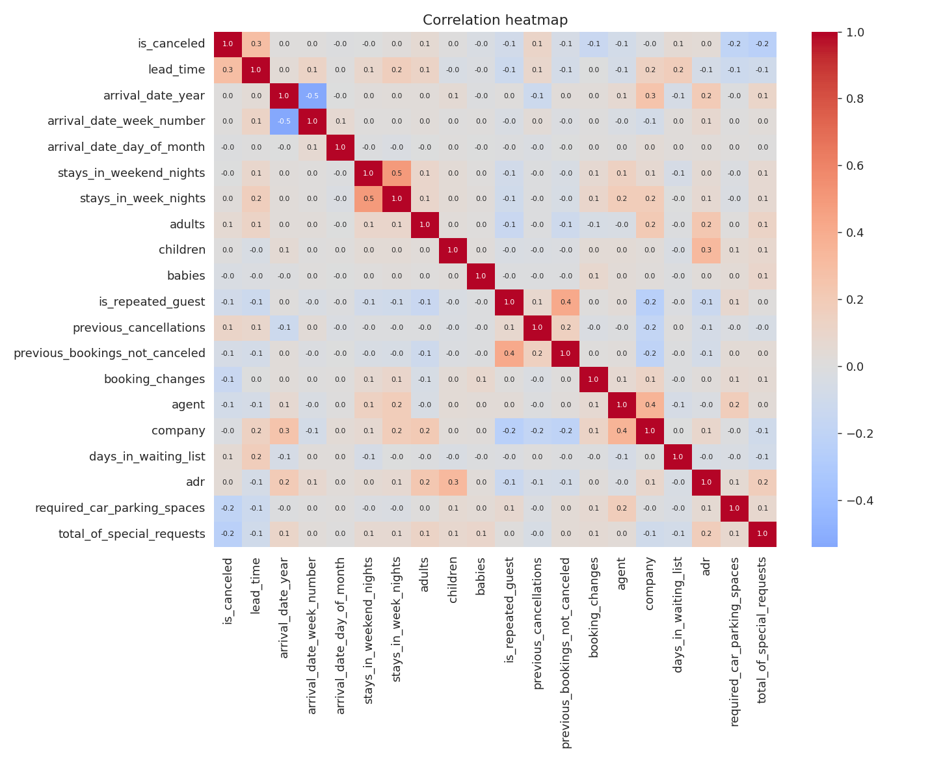
Figure 4: Correlation heatmap of numeric variables
The correlation heatmap shows no pair of predictors with problematic collinearity. The strongest relationship with the target is lead_time (+0.29); the strongest negative ones are special requests (-0.24), parking (-0.20) and booking changes (-0.14). The generally low linear correlations suggest that cancellation depends on combinations and non-linear effects, which motivates the tree-based models.

4. Frequency Distribution of Categorical Variables

4.1 Hotel type
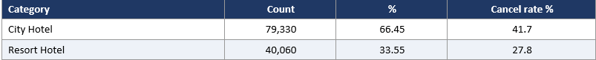Table 4: Frequency distribution of hotel
Two-thirds of bookings are for the City Hotel. City cancels at 41.7% versus 27.8% for the Resort, so the property type shapes risk.

4.2 Market segment
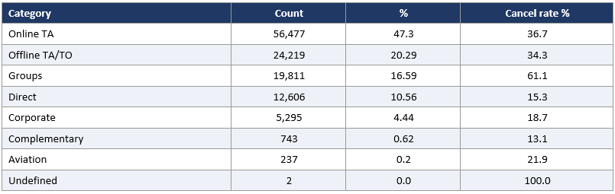Table 5: Frequency distribution of market_segment
Online travel agents (47.3%) and offline TA/TO (20.3%) dominate. Groups cancel at 61.1% - by far the highest among sizeable segments - while Direct (15.3%) and Corporate (18.7%) are the most reliable.

4.3 Deposit type
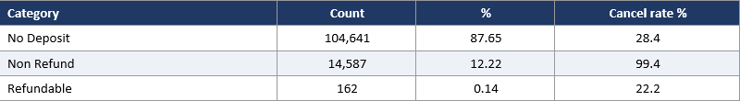Table 6: Frequency distribution of deposit_type
87.7% of bookings carry no deposit (28.4% cancelled). Surprisingly, 99.4% of the 14,587 "Non Refund" bookings were cancelled. This counter-intuitive pattern (a non-refundable deposit should deter cancellation) is a known feature of this dataset, probably linked to specific group/agent practices or to how these bookings were recorded; the model uses it as the single strongest signal, but a manager should treat it with caution rather than as a causal law.
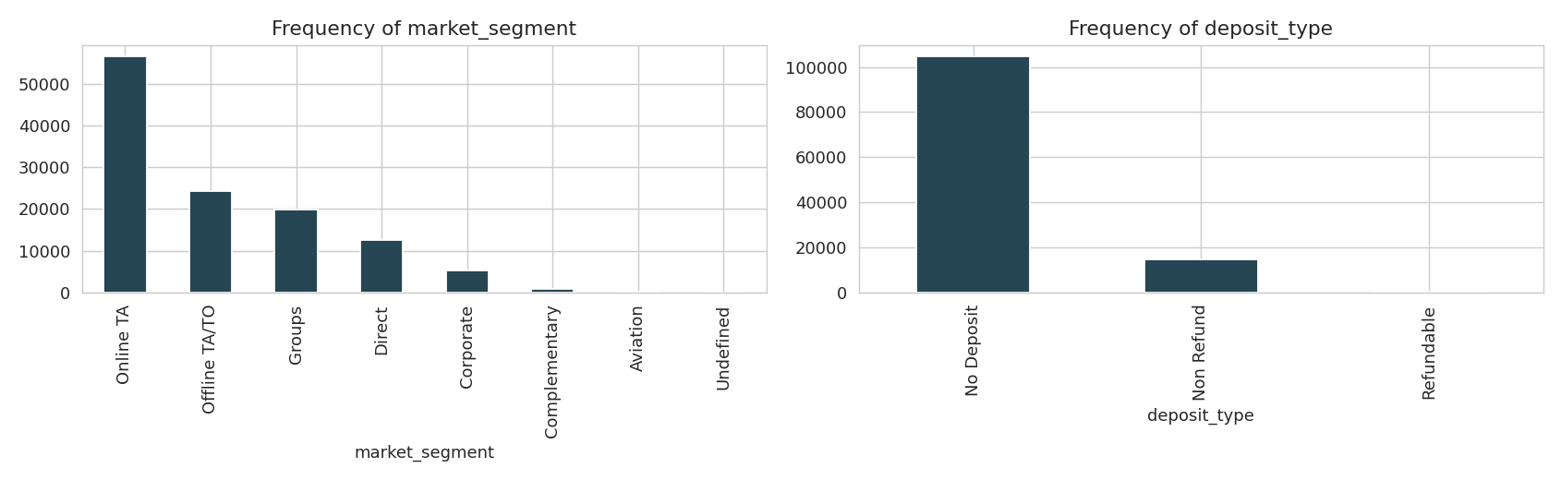
Figure 5: Frequency of market segment and deposit type

4.4 Customer type
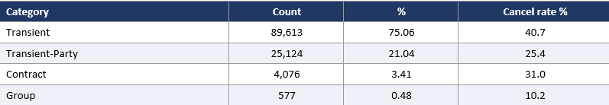Table 7: Frequency distribution of customer_type
Transient guests are 75.1% of bookings and cancel at 40.7%; Transient-Party 25.4%; Contract 31.0%; Group only 10.2% (a small segment of 577 bookings).
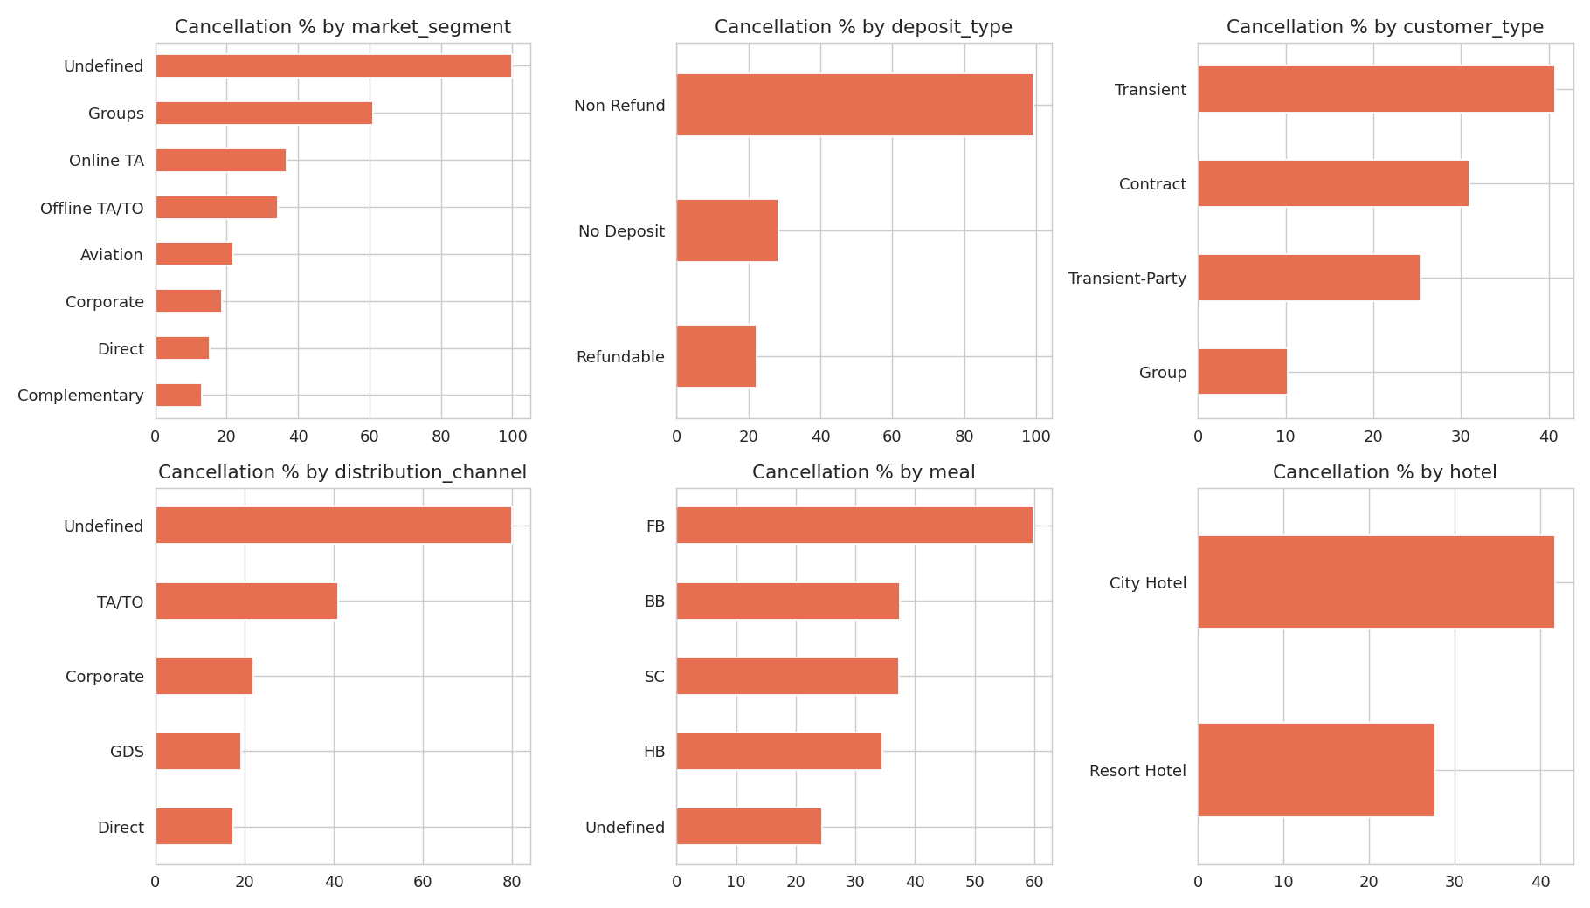
Figure 6: Cancellation rate (%) by categorical variables

4.5 Distribution channel
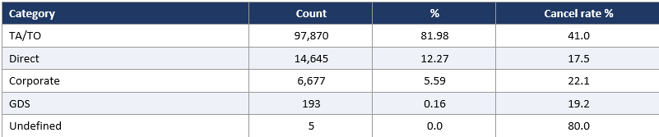Table 8: Frequency distribution of distribution_channel
Travel agents / tour operators supply 82.0% of bookings and cancel at 41.0%, versus 17.5% for Direct and 22.1% for Corporate. Booking direct is associated with commitment.

4.6 Meal plan
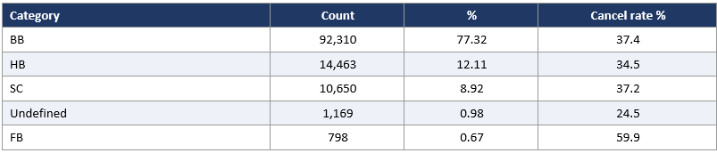Table 9: Frequency distribution of meal
Bed and breakfast (BB) covers 77.3%. Cancellation rates are similar across BB, HB and SC (about 35-37%); Full Board (FB) is rare (0.7%) but cancels at 59.9%.

4.7 Reserved room type
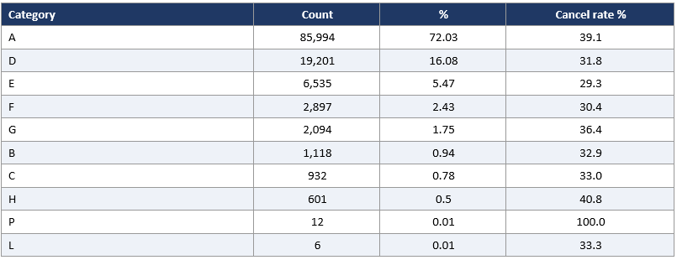Table 10: Frequency distribution of reserved_room_type
Room A is 72.0% of bookings (39.1% cancelled). Other types are smaller with broadly similar rates; types P and L have fewer than 15 bookings, so their rates are unreliable.

4.8 Country (top 10)
Country | Count | % | Cancel rate %
PRT | 48590 | 40.7 | 56.6
GBR | 12129 | 10.16 | 20.2
FRA | 10415 | 8.72 | 18.6
ESP | 8568 | 7.18 | 25.4
DEU | 7287 | 6.1 | 16.7
ITA | 3766 | 3.15 | 35.4
IRL | 3375 | 2.83 | 24.7
BEL | 2342 | 1.96 | 20.2
BRA | 2224 | 1.86 | 37.3
NLD | 2104 | 1.76 | 18.4
Table 11: Frequency distribution of country
Portugal alone accounts for 40.7% of bookings, followed by Great Britain (10.2%) and France (8.7%). Portuguese guests cancel at 56.6%, versus 17-25% for Britain, France, Germany and Spain. Country of origin is therefore a major predictor.

4.9 Arrival month
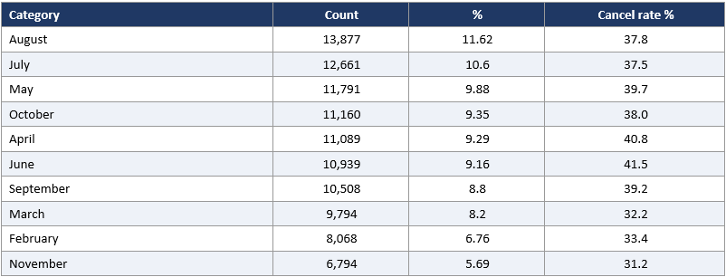Table 12: Frequency distribution of arrival_date_month
Demand peaks in August (11.6%) and July (10.6%) and is lowest in January (5.0%). Cancellation is highest in April-June (about 40-42%) and lowest in January and November (about 31%).
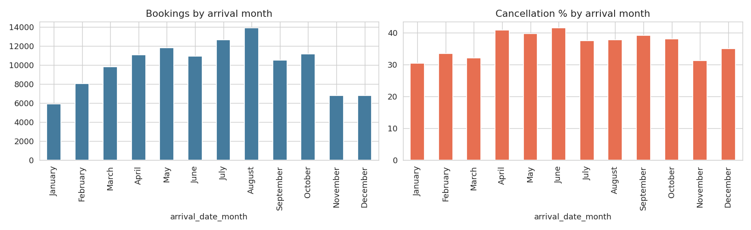
Figure 7: Bookings and cancellation rate by arrival month

4.10 Reservation status (post-outcome field)
Check-Out 63.0%, Canceled 36.0%, No-Show 1.0%. Both Canceled and No-Show are classed as is_canceled = 1, so this field is a perfect restatement of the target. It is therefore excluded from modelling to avoid data leakage.

5. Authenticity of Data and Problem Identification
5.1 Source and authenticity
It is a secondary data published by Antonio, Almeida and Nunes (2019), "Hotel booking demand datasets", Data in Brief, 22, 41-49 (DOI: 10.1016/j.dib.2018.11.126), and is easily available on Kaggle (Hotel booking demand). This includes real property-management-system data relating to hotel stays in Portugal (Algarve resort hotel and city hotel in Lisbon) during the period 1 July 2015 to 31 August 2017. The authors anonymised the data: Guest names or contact and payment information are not provided and the names of hotels are not given. It is then appropriate for academic purposes and we have only been using it for the purposes of aggregate statistical modelling and did not attempt to identify individuals.
5.2 Data-quality findings
We have omitted company and agent as identifiers, as many bookings do not have an agent or company, so this is not missing at random. Children whose parents said they were missing were to be given a value of 0 for missing and "Unknown" for missing country.
•Duplicate Rows: 31,994 rows (26.8%) are duplicated with – 100% of the columns are duplicated. Since there is no booking ID, some of the data are real separate bookings with the same booking properties (e.g. one group booking with multiple rooms in it), and have been left in place, as noted below.
Implausible values: negative ADR (-6.38), ADR of 5400, bookings with no guests, and up to 55 adults. The following were only a few and were reserved for tree models which would be explored in practice with the hotel.
Reservations were made near check in and the outcome is known, so this information was removed, but the information supplied in the notebook (assigned_room_type) was kept for comparability and is marked as a leakage risk.
5.3 Limitations of the data
Only 2015-2017 – results may not apply to other markets, or to behaviour after the pandemic.
No currency, hotel names and price context disclosed; the impacts of the strong Portugal and Non-Refund indicators might just reflect the local booking practices.
No booking ID, which means not being able to be certain about duplicate records definitively; no info on the cancellation date in relation to arrival.
5.4 ML problem definition
The task is binary classification: provided information that is available at the time of booking, predict is_canceled. The main measure of success for the cancelled class is recall and F1 (missed cancellations are costly), and for ranking quality is ROC AUC. The problem itself is ideal for ML as the output, a risk score per booking, can be directly acted upon in the context of overbooking or deposit decisions, as the relationships are non-linear and combinatorial, and the sample is quite large (119,390).

6. Analysis
6.1 Methodology
•Arrival month was converted to a number; country was reduced to top 10 countries plus Other; categorical variables were one-hot encoded (drop-first) to result in 69 predictors.
•Train-test split: 70% / 30% stratified (83,573 train / 35,817 test), random_state = 42.
Scaling: StandardScaler fitted on the training set and applied to the test set.
Class Imbalance: SMOTE only on the training set, resulting in 52,616 instances for each class. The test set has the same 63/37 ratio as the natural sample to provide scores that reflect actual conditions. Applying SMOTE prior to splitting, as described in the draft notebook, causes synthetic copies of neighbours in the test set to also be added to the training set, thus overestimating all scores, so the pipeline was adjusted accordingly.
Rejected models: XGBoost and DeepTree which are complex non-linear models.Models: Logistic Regression (baseline and interpretable), Decision Tree with max depth 5 (rules interpretable), and Random Forest (non-linear ensemble). The Random Forest was then tuned using RandomizedSearchCV (with 20,000 rows sampled from the training set to speed up tuning, and CV type: 2-fold CV, using 100 trees, with no depth-limiting for the trees and min_samples_leaf = 1) and the optimal settings were retuned on the full balanced training set..

6.2 Model comparison
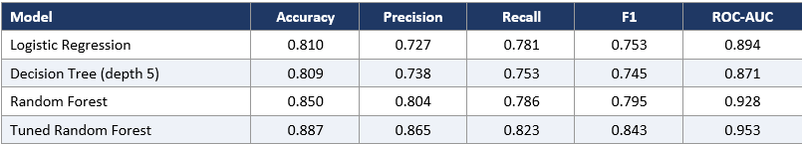Table 14: Test-set performance (positive class = Canceled)
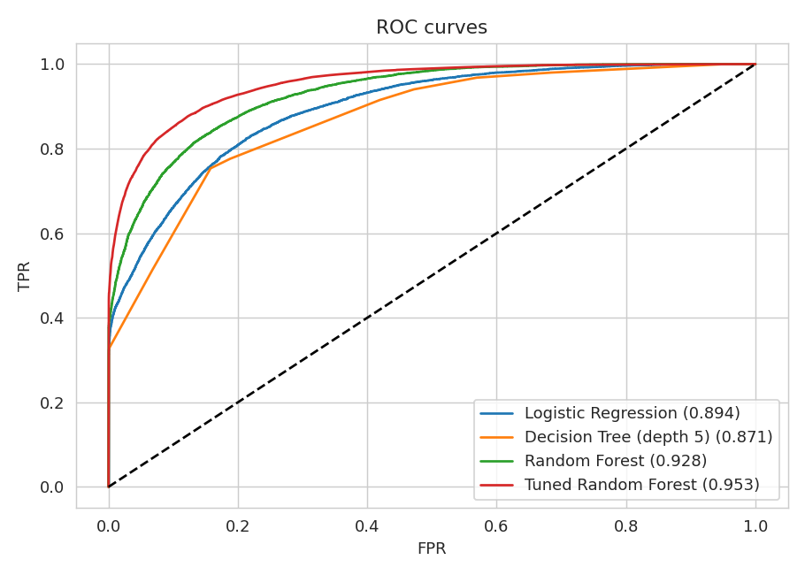
Figure 8: ROC curves of all models
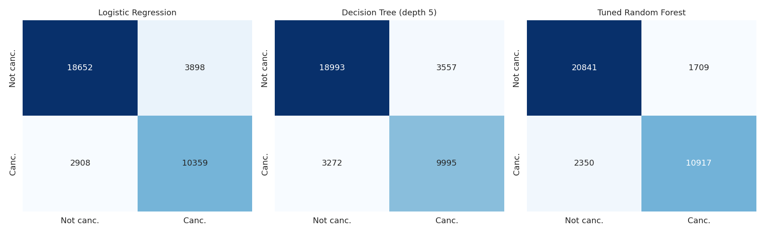
Figure 9: Confusion matrices
Reading the table: the Logistic Regression and Decision Tree reach about 81% accuracy and F1 near 0.75. The untuned Random Forest improves to 85.0% accuracy and F1 0.795. The tuned Random Forest is best on every measure: accuracy 88.7%, precision 0.865, recall 0.823, F1 0.843 and ROC-AUC 0.953. For the tuned forest, 10,917 of 13,267 cancellations in the test set were correctly caught (recall 82.3%), at the cost of 1,709 false alarms among 22,550 honoured bookings. Precision of 86.5% means that about 7 in 8 bookings flagged as high-risk really do cancel.

6.3 Feature interpretation
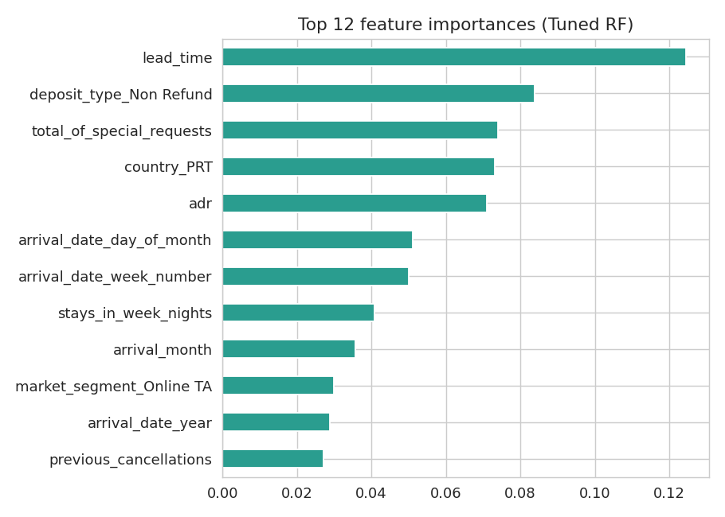
Figure 10: Top 12 feature importances (tuned Random Forest)
The top 6 factors are lead time, Non-Refund deposit, number of special requests, Portuguese origin, arrival week/day/month and previous cancellations. The direction of the Logistic Regression coefficients matches: previous cancellations (+1.97), Non-Refund deposit (+1.57), Portuguese origin (+1.14), Online TA segment (+0.86) and lead time (+0.50) increase the chances of canceling, while required parking spaces (-2.21), special requests (-0.65) and previous completed stays (-0.61) decrease the chances of canceling. Importances tell about what variables are used by the model, but do not indicate that they cause a cancellation.
6.4 Knowledge of the transparent and ethical use of tools that make use of artificial intelligence.
An AI assistant (Claude) was used to run the analysis pipeline, generate charts and draft this report from the group's notebook and dataset. The group has reviewed and is responsible for the results, can explain each step, and the AI tool is used following the institute's guidelines related to plagiarism and AI. All codes and data are submitted in GitHub to reproduce the results. Turnitin report will be submitted separately.
The conclusions of the Study
7.1 Conclusions
Predictability of cancellation at booking time is very high: the tuned Random Forest achieves an AUC of 0.95 and a precision rate of 86% on the cancellations problem, compared to the linear baseline (AUC 0.89) and the shallow-trees baseline (AUC 0.87). Non-linear interactions matter.
•Risk is concentrated. The highest-risk bookings are Portuguese-origin bookings on the group and online-agent channels with no special requests and long leads, and cancellations in the past. The ones with the least risk are direct, corporate, repeat and parking-booking guests.
Compared to the Resort (27.8%) and spring (April-June), the City Hotel is cancelled more than any other (41.7%).
7.2 Actionable recommendations
Do not use a percentage based on seeing how many bookings you can fill; use a model score for overbooking in a selective and risk-prone manner - fill more bookings with high scores.
Provide a reward scheme for agent to direct bookings and remind / request deposits for long-lead bookings.
•Encourage guests to add special requests and parking (small personalisation steps that are associated with commitment).
Revisit the Non-Refund bookings – a 99.4% cancel rate means there is data or process related problem that needs to be addressed with the hotel as this policy is not working.
7.3 Limitations and future work
The results are compiled from 2 Portuguese hotels for the 2015-2017 period, and they rely on a single random splitting – it would be a more rigorous test if split out by time. The Non-Refund anomaly, along with the duplicate rows, could inflate accuracy, and leakage via assigned_room_type might be a possibility. The recall of 82% is still the suboptimal, meaning that approximately 1 out of 6 people who are invited to stay at a hotel will not be accepted, and there is a potential of making false positive when it comes to accepting or denying an invitation, so the model should not replace hotel manager decisions but should be there to aid them. Future work: time based validation, gradient boosting (XGBoost / LightGBM), probability calibration, threshold tuning against actual cost of an empty room versus a walked guest, and removal of assigned_room_type.

8. Understanding the problem and algorithms conceptually
Exploratory data analysis: Descriptive data summarise centre and spread, long-tailed variables are indicated by skewness and the mean-median gap, the frequency table shows that the risk is concentrated at certain values, and the correlation indicates a linear association only.
•SMOTE: Interpolates a synthetic example of the minority-class between a cancelled booking and its adjacent cancelled neighbours. It should only be used for training data, otherwise it would be optimistic for evaluation.
Logistic Regression: models the log odds of cancellation as a linear combination of features. It has interpretable (sign and size of effect) coefficients and cannot model interactions alone.
•Decision Tree: repeatedly splits the data on feature and threshold which best separates cancelled and non-cancelled bookings (Gini impurity), and yields readable rules and low overfitting, but also low accuracy; shallow depth.
Random Forest: Is a averaging of many trees trained on the bootstrap samples with random feature subsets (bagging), it reduces variance of a single tree and accounts of non-linear interactions; feature importance is based on total impurity reduction.
Evaluation metrics: together accuracy is misleading because classes are imbalanced, precision (how many flagged bookings that really cancel) and recall (how many cancellations that are flagged) are used, together with the F1 (precision & recall balance) and the ROC-AUC (ranking quality at all thresholds). The degree of precision and recall depends on the cost to the business for each type of error.
Hyperparameter tuning: RandomizedSearchCV is an alternative to exhaustive grid search that performs cross validation for each of the sampled settings (trees, depth, leaf size).

Referencing and submission items
•Antonio, N., Almeida, A., & Nunes, L. (2019). Hotels bookings data. Data in Brief, 22, 41-49. https://doi.org/10.1016/j.dib.2018.11.126
The data used is the secondary data named "Hotel booking demand" from Kaggle (hotel_bookings.csv).
•Chawla, N. V., et al. (2002). The SMOTE: Synthetic Minority Over-sampling Technique is a method of increasing the minority class. Artificial Intelligence Research, 16, 321-357.
•Breiman, L. (2001). Random forests. Machine Learning, 45, 5-32.
•Pedregosa, F., et al. (2011). Scikit-learn: Python machine learning library. JMLR, 12, 2825-2830.
Items that should be shared by the group:
dataset: https://www.kaggle.com/datasets/jessemostipak/hotel-booking-demand
GitHub – repository link to be added: https://github.com/guptakushagra9719-gif/ML-Hotel-booking

